**Worksheet 2: Highway Hazards**

While cruising along a dark stretch of highway with the cruise control set at 25 m/s (≈55 mph), you see, at the fringes of your headlights, that a bridge has been washed out. You apply the brakes and come to a stop in 4.0s. *Assume the clock starts the instant you hit the brakes.*

1. Construct a motion map that represents the motion described above, including position, velocity, and acceleration. Clearly demonstrate how you can determine the direction (sign) of the acceleration from the motion map representation.

2. Construct **qualitative** graphical representations of the situation described above to illustrate:

a. **x** vs. **t**

b. **v** vs. **t**

c. **a** vs. **t**

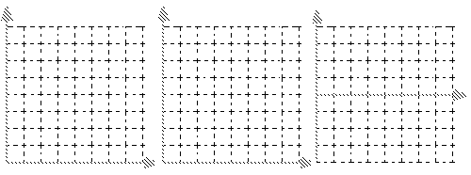

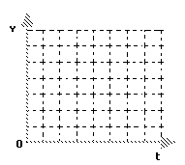3. Construct a **quantitatively accurate** **v** vs **t** graph to describe the situation.

4. On the **v** vs **t** graph at right, graphically represent the car’s displacement during braking.

5. Utilizing the **graphical representation**, determine how far the car traveled during braking. (Please explain your problem solving method.)

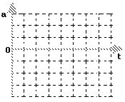

6. In order to draw the **a** vs **t** graph, you need to determine the car’s acceleration. Please do this, then sketch a **quantitatively accurate** **a** vs **t** graph

**Computer simulation:**

A blue car is travelling down the road in Assateague, when the driver notices a herd of wild horses crossing the street. Your goal is to find the acceleration, initial velocity, and position-to-start-braking required to stop the car without hitting any horses AND achieve the MAXIMUM score.